**Employee Attrition Prediction using Machine Learning Algorithms**

**Lok Sundar.G1, Yaswanthi.N1, Deepalakshmi.P3, Krishnakumar.M4**

Department of Computer Science and Engineering, 1,2,3

Kalasalingam Academy of Research and Education, Tamilnadu, India. 1,2,3

[loksundar000@gmail.com](mailto:loksundar000@gmail.com)1, [nyaswanthi6@gmail.com2](mailto:nyaswanthi6@gmail.com2), deepa,kumar@klu.ac.in3,

Director IT, COE Leader – Build, MicroPlus, Bangalore.4

krish.india.blr@gmail.com4

**Abstract:** In any corporation, if a significant number of employees leave their job with a short notice period, it may lead to a reduction in overall throughput which in turn will certainly have an impact on the turnover. Companies need to spend additional efforts in terms of time and cost to fill up the vacant position without any substantial loss to the ongoing business. To avoid these situations, we can use machine learning techniques to predict employees who are planning to leave the company with the help of some related data. One more way is to identify the features which inspire employees to leave their job. Refining such features in the company also will result in reducing the employee attrition rate of the company. In this paper, we attempted to predict employee attrition rate using the classification algorithms namely Decision tree, Random Forest, K-Nearest Neighbourhood, Neural Networks, eXtreme Gradient boosting and Ada-Boosting. We also have applied regularization for every algorithm to find the precise parameters to predict the employee’s attrition rate considering the HR data set from the Kaggle website which consists of 35 features including 34 independent and one dependent feature which is our attrition feature with Yes/No values in it. In this paper, we are going through different steps to finally obtain an accuracy of 88% with good precision and recall values.

**Keywords**: Attrition rate, Classification algorithms, Decision tree, Random Forest, K Nearest Neighbourhood, Neural Networks, eXtreme Gradient boosting, Ada-Boosting, Regularization parameters, HR dataset and Kaggle.

**1. Introduction**

Employee attrition will affect a company in many ways. If any employee leaves an organization, more focus is on knowledge transfer than any other productive work. Finding a suitable replacement for all kinds of roles may not be easy and sometimes even a lengthy process including the additional training time to improve the skills of the new joiner. The team, from where the employee leaves or about to leave, its performance will get decreased and the work pressure among the team members will also increase.

To avoid such scenarios, the HR team tries different ways to know which employee is not sustained in the current role. Then, the HR team motivates such employees to avoid the drop-out movement. Prediction of employee attrition in advance and taking preventive measures play a valuable role in maintaining the company‘s productivity. So, an automated approach using machine learning algorithms to predict employee attrition has become an essential need for every company to avoid unexpected employees dropout and costs to train new employees.

**2. Related Works**

From several years onwards, many types of research are done on predicting employee turnover and many new models have been introduced both practically and theoretically. In recent periods, predictions are done using statistical analysis techniques.

Storey [1] stated that the success of an organization is dependent on holding employees along with job satisfaction. He observed that a lack of job satisfaction or factors regarding the workplace is the main reasons for attrition. Attrition takes place because of several reasons including an imbalance in work- personal life, poor knowledge of the field, poor management as well as poor compensation. These factors make the employee leave the current job and look for a better one. At the same time, if problems associated with the working place are solved, the attrition rate decreases notably.

Jantan [2] applied c4.5 Decision tree, Random Forest, Multilayer Perceptron and Radial Basis Functional Network for the employee turnover problem. Based on the results, the authors recommended the C4.5 Decision tree as the most promising approach for the data set they considered. Nagadevara [3] considered the relationship of withdrawal behaviours like lateness and absenteeism, job content, tenure and demographics on employee **turnover**and applied Artificial neural networks, logistic regression, classification and regression trees (CART), classification trees (C5.0), and discriminant analysis to predict attrition rate. The authors finally stated that Random Forest with Decision trees offered the best performance.

Pankaj Ajit [4] took various algorithms like Logistic Regression, Naïve Bayesian, Random Forest (Depth controlled), SVM (RBF kernel), Linear Discriminant Analysis LDA, KNN (Euclidean distance) and XGBoost to apply on the same data set which we are using in this paper. He found that the XGBoost algorithm performs better among the remaining algorithms he used.

Joao Marcos de Oliveira [5] attempted to predict employee attrition using Neural Networks, Recurrent Neural Networks and Gated Recurrent Neural Networks. The authors found that Gated Recurrent performs well when the data is balanced and Recurrent Neural Networks performs better when the data is unbiased. As the data we consider for our study is imbalanced in terms of attrition class, we are using Recurrent Neural Networks for performance comparison.

Xiang Gao [6] performed employee attrition prediction using a Decision tree, Random Forest, Back Propagation Neural Networks and Logistic regression. After comparing the performance of these algorithms based on the ROC curve, the authors stated that Random forest’s performance is superior compared to other algorithms.

Yue Zhao [7] published a paper on employee attrition prediction using machine learning algorithms. The machine learning algorithms they used are decision tree, random forest, gradient boosting trees,

extreme gradient boosting, a logistic regression, support vector machines, neural networks, linear discriminant analysis, Naïve Bayes method and K-nearest neighbour method. The authors concluded that XGB, Decision Tree, Random Forest and Neural Networks perform well for the dataset they considered.

Rahul Yedida [8] did employee Attrition Prediction in which he compared KNN, Naïve Bias, Logistic Regression and MLP classifier and reported the superiority of KNN classifier in terms of accuracy and predictive effectiveness through the ROC curve observation. When used with its optimal configuration, it is a robust method that delivers accurate results despite the noise in the dataset, which is a major challenge for machine learning algorithms.

Yoon [9] stated that the key role of the HR department is to identify the characteristics and needs of every employee personally and some associated information related to employee attrition. The authors made research among the employees serving in five-star hotels and found that job satisfaction is an important factor affecting turnover. They have researched how giving priority to an EMC error management culture results in more job satisfaction and less turnover.

Labrague [10] researched attrition rate prediction among nurses working in Philippines hospitals. The authors concluded that age, job satisfaction, and job stress are the factors that mostly affecting attrition. However, they used the Apriori model which is not accurate since extracted features for employee attrition work well in rare cases only. Amir [11] implemented knowledge discovery steps on real employees data of a manufacturing plant. They chew over many characteristics of employees such as age, technical skills and work experience. They used the Pearson Chi-Square test to find out the importance of data features.

              In this paper, we attempted to use six classification algorithms, Decision tree, Random Forest, K Nearest Neighbourhood, Neural Networks, eXtreme Gradient boosting and Ada-Boosting to identify the best-fit algorithm for employee attrition problem and to build a model for predicting the future employee attrition rates and predictions. We used the Ada Boosting model, one of the best ensemble Machine Learning Technique for unbiased data because, in Ada-boosting, we take care of both weak trees and strong trees into consideration by giving the trees their appropriate weights depending upon their error measures.

**3. Methodology**

The methodology we used in this paper as illustrated in Fig.1 is based on the classic Crisp DM model. Primarily, we will start with the data understanding and then move to preparation and modelling. In the modelling, we used six different machine learning algorithms to see which model performed best among all. Based on the results obtained, we consider the best method and build the model based on it.

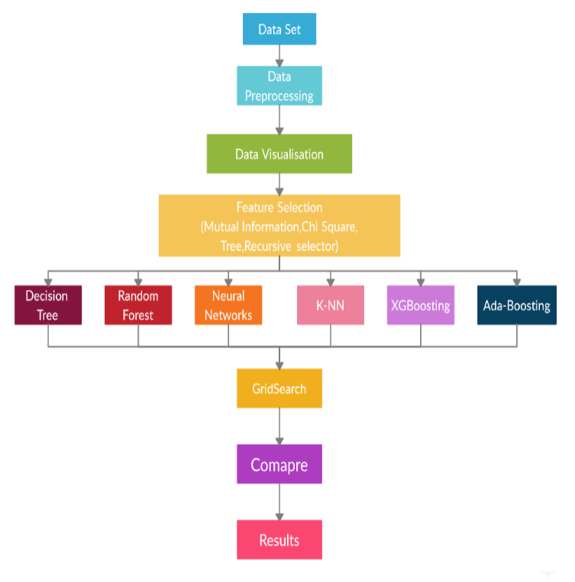

**Fig. 1.** Methodology Flow

**3.1 Data-pre-processing:**

The HR-data set from Kaggle contains 35 features in which 34 are independent features and the remaining one is a dependent feature which is our output. Fig. 2 lists all the features of the data set along with the possible values each feature can take, its data type and also an indication if there are any null values in the data The features are almost self-explanatory from their names themselves.

The features in this data set are of different data types like categorical, binary and numerical. This required us to convert every feature into numerical form to ease the calculations as many models work with only numerical data, in addition to pre-processing the data. The feature engineering can give a better accuracy score as it removes unwanted features. To start with, we first converted the categorical data to binary numeric data using an encoding script that uses a dictionary concept.

**3.2 Data Visualization**

In this phase, we are plotting different types of graphs including heat maps as shown in Fig. 3, correlation graphs, counterplots, histograms and distribution plots among various features as shown in Fig.4 (a-d) to understand the relations between different features to target features.

/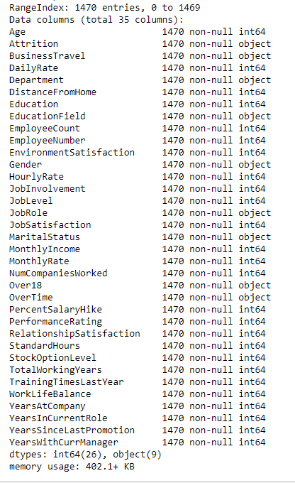

**Fig. 2.** Features, count and data types of considered data set

.

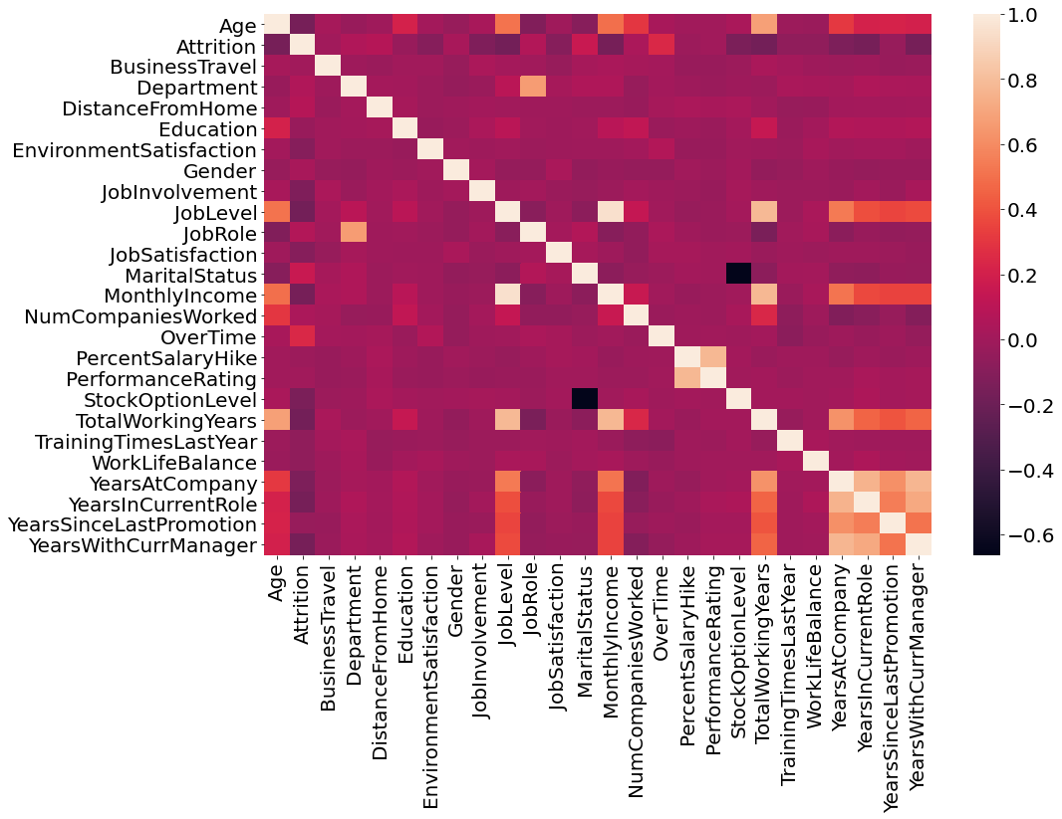

**Fig. 3.** Correlation Heat map of all features

Fig.3 is about the correlation heatmap of all features in the data set. It tells us about the correlation among all the features ranging from 0 to 1 in the White-Red-Black scale. Each box in the matrix shows how correlated the two features are in the dimension of the White-Red-Black scale.

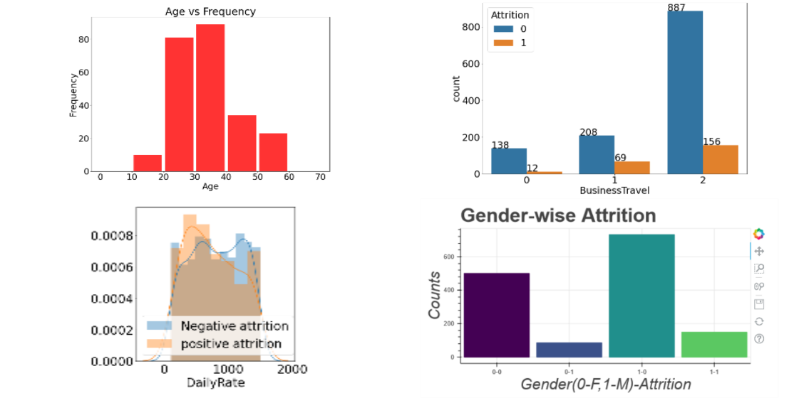**Fig. 4.** Data Visualization : (a) correlation graph , (b)counter plot, (c) histogram and (d) distribution plot

Figure 4 shows the collection of the different types of graphs that we used in the problem to visualise the insights and to explain them graphically. There are about 26 graphs in total but because we consider these four graphs because these four are commonly used graphs.

**3.3 Feature Engineering**

In this step, we can divide all the features we are having into two categories, Continuous Numerical and Categorical Data with String values and Ordinal Data.

1. *Continuous Numerical Features* *:- 'Age', 'DailyRate', 'DistanceFromHome', 'Education',’ Employee Count’, ‘Employee id’, 'HourlyRate' ,'JobLevel', 'MonthlyIncome', 'MonthlyRate', 'NumCompaniesWorked', ’Over18’, 'PercentSalaryHike', ‘StandardHours' , TotalWorkingYears', 'TrainingTimesLastYear', 'YearsAtCompany', 'YearsInCurrentRole', 'YearsSinceLastPromotion', 'YearsWithCurrManager'.*

From the above variables Employee Count, Over 18 and Standard Hours are constant variables. They are having constant value for all the entries so these variables don’t make any sense in the prediction so we removed them. And Employee id is unique for each employee so we removed this one also. After removing these 4 variables, we will scale the remaining variables by using the standardization scaling formulae as specified in the following equation

$Xnew=\frac{Xold- u}{σ}$ (1)

where µ = mean, σ = standard deviation.

1. *Categorical Features (String values):* The features 'BusinessTravel', 'Department', 'EducationField', 'Gender', 'JobRole', 'MaritalStatus' and 'OverTime' are categorical features we will do one-hot coding on them to convert these variables into Boolean forms. We are doing this because we don’t know which variable is Ordinal or Nominal, So we are doing one hot encoding for these and we will remove original features from the data. After doing one hot encoding we will get 51 features in total.
2. *Ordinal Data:* we will not do any modifications to these features as they are in their best shape.

**3.4 PCA(Principal Component Analysis) :**

As we know that principal components cannot be performed on categorical variables along with numerical variables, we separate the continuous numerical variables and perform PCA operation on them. There are a totally of 13 numerical features and we draw an elbow curve for them to pick the best number of features without losing more information.

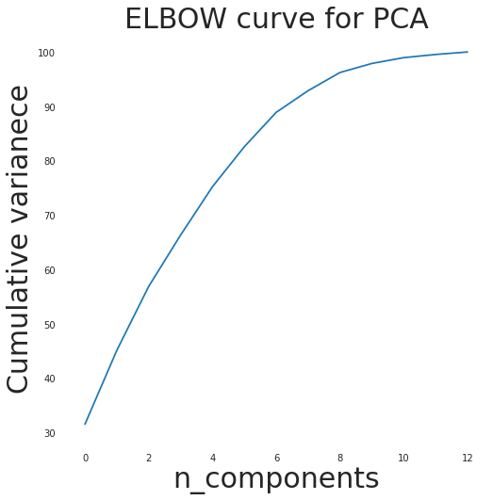

**Fig.5.** Choosing the best number of principal components using Elbow Curve method.

The cumulative variance values are array ([ 31.51160882, 45.10839722, 56.86614763, 66.30600138, 75.2075295 , 82.56779817, 88.89630377, 92.87309077,

96.22304125, 97.88298146, 98.95452676, 99.53852271, 100. ]). From these values, we observe that the change in variance from 8th to 9th is 3.5 and the information covered is up to 93% which indicates that we can take eight features. Hence, out of 13 numerical variables, PCA recommends 8 features.

**3.5 Feature selecting**

After applying the Mutual Information method, Recursive Method, Tree selector method and Chi-square method to all features concerning attrition, we consider only the top 15 features from each method and we will join them into a set. As a result, we will get 23 features listed as follows. Along with these 23 features, we add our 8 PCA features and hence totally we will get 31 features.

|  |
| --- |
| *'BusinessTravel_Non-Travel 'BusinessTravel_Travel_Frequently', 'Department_Sales' 'EducationField_Human Resources' 'EducationField_Life Sciences' 'EducationField_Technical Degree', 'EnvironmentSatisfaction', 'JobInvolvement',*  *'JobRole_Healthcare Representative', 'JobRole_Human Resources', 'JobRole_Laboratory Technician', 'JobRole_Manager', 'JobRole_Manufacturing Director', 'JobRole_Research Director', 'JobRole_Sales Representative', 'Job Satisfaction', 'MaritalStatus_Divorced', 'MaritalStatus_Single',*  *'OverTime_No', 'OverTime_Yes', 'RelationshipSatisfaction', ' StockOptionLevel'*  *'WorkLifeBalance'.* |

**4. Algorithms Used**

**4.1 RFE - Recursive feature eliminator or Recursive Selector**

RFE works by searching for a subset of features by starting with all features in the training dataset and successfully removing features until the desired number of features remains This is done by fitting the given machine learning algorithm used in the model, ranking features by importance, discarding the least important features, and re-fitting the model. This process is repeated until a specified number of features remains. Features are scored either using the provided machine learning model (eg: Decision tree, Random forest etc .., ) or by using a statistical method.

**4.2 Tree Selector:**

Tree selectorworks the same as RFE but in the feature scoring algorithm, it always uses the Decision tree as its algorithm. The decision tree uses either entropy or Gini as its scoring index criteria.

**4.3 Decision Tree:**

Decision trees are useful when data possess nonlinear patterns present in them. It is represented as a flow chart in which internal nodes represent the test on a particular feature and the branches represent the output of the test and the child node represents the class in which the input/item is classified.

We consider Entropy as the splitting constraint. The decision tree which we get for the employee attrition prediction is shown in Fig. 6. The formula for the Entropy is given by the following equation.

Entropy(S) = ∑-pi*log2(pi) (2)

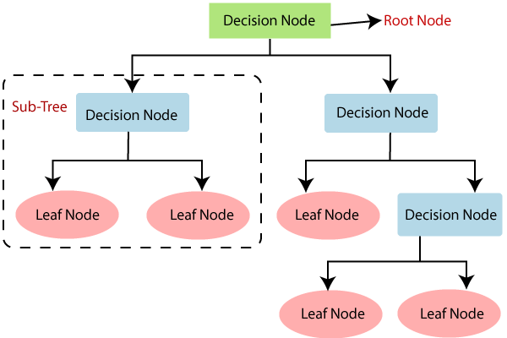

**Fig .6**. Illustration of Decision tree Working Principle

**4.4 Random Forest**

The working principle of the random forest method is given in Fig. 7. It constructs several decision trees using the CART procedure and the output will be either mean or mode of all trees present in a random forest. This helps the algorithm to avoid overfitting.

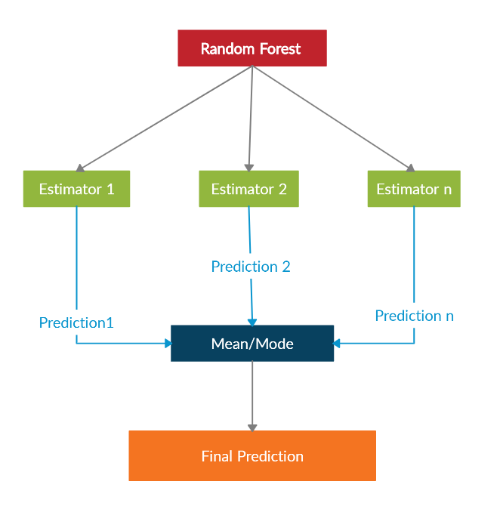

**Fig. 7.** Illustration of Random Forest Woking Principle

In a random forest, we use Mean Squared Error(MSE) to identify how our data branches from each node.

MSE = ∑i(fi-yi)2 (3)

where yi = Actual data, fi = Predicted data, N = Total number of data points

This formula calculates the distance of each node from the predicted value, helping to decide which branch is the better decision for your forest. While performing random forest we can use either Gini-index or entropy as the criteria for the splitting of nodes in decision trees. The formulae for the Gini-index is

Gini = 1-∑(p2) (4)

The formulae for the Entropy is

Entropy(S) = ∑-pi*log2(pi) (5)

**4.5 Neural Networks**

Neural networks are mostly used for image classifications and computer vision to learn patterns on the unstructured data. As we know that neural networks work best for unstructured data, it is capable of taking out difficult patterns from data. Since our data is biased, we selected neural networks to find how best this works for our problem.

The input for each neuron can be given by z=wTx+b where WT is a weight vector and b is the bias. The output of the neuron is y = g(z) in which the function g is called a sigmoid function. The loss function can be given by

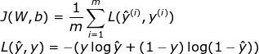 (6)

The sigmoid function is given by

G(x) = $\frac{1}{1+e^{-x}}$ (7)

**4.6 K-Nearest Neighbourhood**

KNN algorithm works based on geometrical principles. This algorithm plots all the points in the multi-dimensional plain and then indexes them according to their class. When a new point enters, it gets plotted on plain and then takes the mode of the k nearest points as the class of it. It works best for classification models when there exists a geometrical relationship present among the features of the data.

**4.7 extreme Gradient Boost (XGB)**

XGB algorithm is an advanced version of Random forest. In the random forest, each subtree is independent but in the XGB model the trees are interlinked and error in the current tree is adjusted through constructing consecutive trees by reducing errors. Every tree has some weight in the final prediction of the model according to its error rate.

The main formulae’s we use in the XGB is

similarity score = ƩƟ / (ȅ +λ ) (8)

where λ is used for regularization which varies between 0-1 and

Ɵ = error residual= difference between the predicted and expected values

ȅ = error samples

**4.8 Ada Boost Algorithm**

This model is constructed by ensembling weak learners. Here linear regression is used as the weak learner for regression models, stumps as the classification models. Stump is a tree with one parent node and two leaf nodes and works similar to the trees in XGB. Each consecutive stump is created to overcome the errors of previously constructed stumps. Adaptive Boosting algorithm performs better on unbalanced data.

**5 Experiment**

**5.1 Regularization**

For each model, we apply regularisation by changing the parameters and drawing graphs concerning the accuracy and parameters. After analysing it, we can select the best parameters and include these model parameters for the final comparison.

The data set used in this paper contains 35 features in which 32 features are useful for the prediction of attrition not including employee name, S.No and employee_id. From the data visualization step, we identified only 15 features as important. The output variable is a binary variable having the value of Yes / No indicating the prediction of employee movement. For our experiment, we used 70% data from the data set for training and 30% for testing. The graphs are as follows:

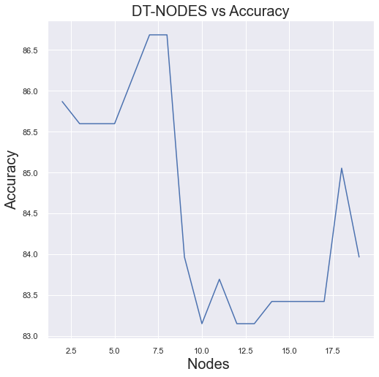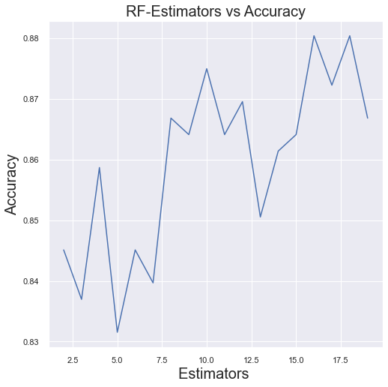

**Fig.8.** Regularizing Parameters of Decision Tree and Random Forest

From Figure 8, we could finalize regularized parameters for the D-tree algorithm as 40 nodes and for Random forest, the regularized value for the number of estimators is around 20. From Figure 9, we take regularized parameters as Depth = 3 and Estimators = 40 for the XGBoost algorithm.

From Figure 10 regarding regularized parameters, for KNN, we observed that k’s regularized value is five since from the graph we observe that the accuracy is the same along 5-10. For AdaBoost we can take 20 estimators as the regularised value because we observe that there are very few fluctuations and graphs seem to be constant from 30 - 60, so we took 40 as a regularized value.

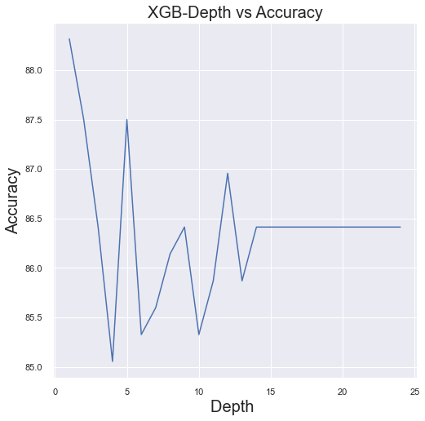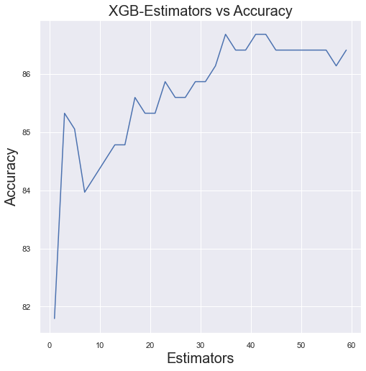

**Fig.9.** Regularizing parameters Depth and Estomators for the XGBoost model

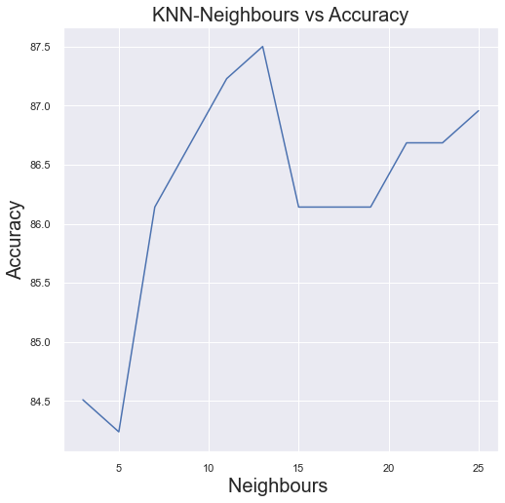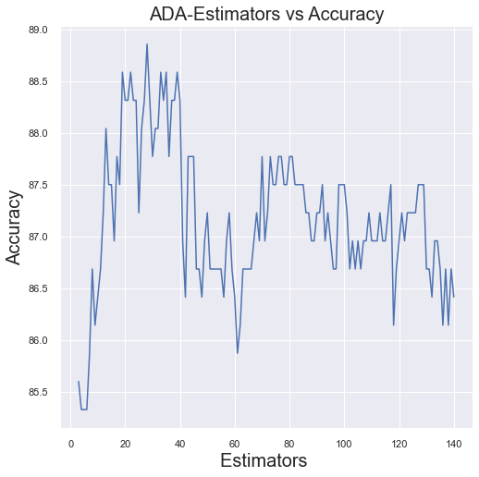

**Fig. 10.** Regularizing Parameters of KNN and Ada-Boost Algorithms

From the above graphs, we got the regularized parameters for all the algorithms. Now, we will use these parameters for the final comparison of all the algorithms.

**5. Implementation**

To implement the considered algorithms, we used Jupiter IDE of the Anaconda platform in 3.8.2. Since our data consists of 83% entries of the employees with attrition value as ‘0’ and 17 % entries of the employees with attrition value as ‘1’, we take harmonic mean of each metric like precision, recall and f1 score. When we are using the confusion matrix to find metrics, the resulting values we get are only dependent on the ‘1’ cases. In our model, it is about the attrition of positive employees. Hence, it will not see the ‘zero’s’. So, now we calculate precision, recall and F1-Score regarding zero’s also and we will take harmonic mean of both one’s and zero’s to get the final precision, average and F1-Score values.

Harmonic mean of a and b = 2*a*b/(a+b) (9)

**5.3 AUC-ROC for Each Model**

In Machine Learning, performance measurement is an essential task. So when it comes to a classification problem, we can count on an AUC - ROC Curve. When we need to check or visualize the performance of the multi-class classification problem, we use the AUC (**Area Under The Curve)** ROC **(Receiver Operating Characteristics)** curve. It is one of the most important evaluation metrics for checking any classification model’s performance. It is also written as AUROC (**Area Under the Receiver Operating Characteristics).** AUC ROC curve is a graph between the True Positive Rate and False Positive Rate where

True Positive Rate = $\frac{True positive }{True Positive+False Negative}$ (10)

False Positive Rate = $\frac{False positive }{False Positive + True Negative}$. (11)

The AUCROC curves for the six classification models we have considered in this paper are plotted in Fig. (11 -16)

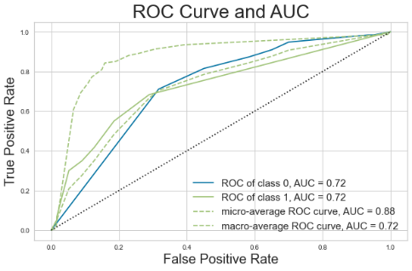 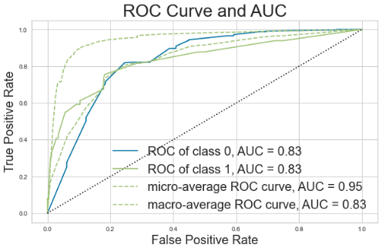

***Fig.*11.** AURUC of Decision tree model ***Fig.*12.** AURUC Random Forest model

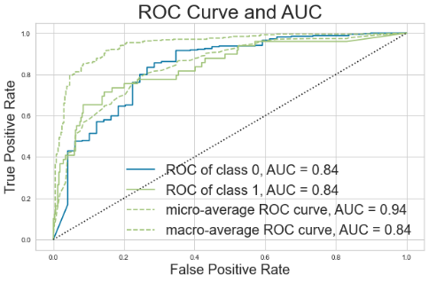 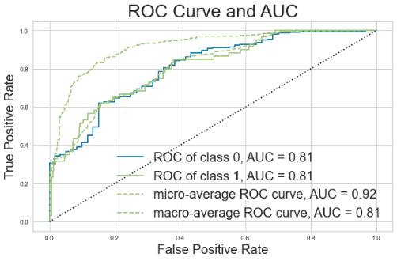

***Fig.*13.** AURUC of KNN model F***ig.*14.** AURUC Neural Networks

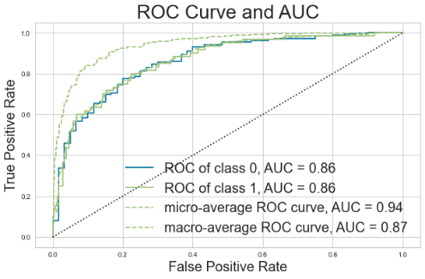 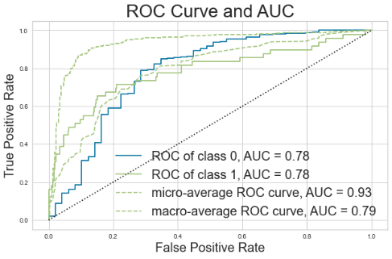

***Fig.*15.** AURUC of XGBoost model ***Fig.*16.** AURUC of Ada boost model

From the above figures, we can observe that even in the AUCROC curves considering each criterion, the XGBoost outperforms when compared with the remaining five algorithms that we considered

**6 Results:**

The results which we get when we use harmonic means of classes are as follows. From Fig. 17, we can understand that XGBoost performs best compared to the remaining algorithms with an accuracy of 88% and an F1 score of 0.87. Since its Recall score is greater than the Precision score, it says that false negative is greater than false positives. So, Type 2 errors are very low. One more observation here is that the precision, recall and f1-score values are a little low because we are not giving importance to only classify into one’s (attrition positive) but also for zero’s (attrition negative).

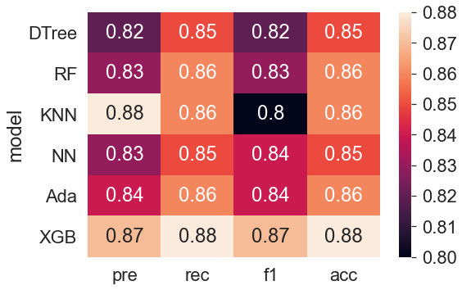

***Fig.*17.** Heat-map of the results for Performance Comparison.

Fig. 17 Shows the Heat map comparison of results of our models graphically. Each row is of different models among the six ML Algorithms considered and each column is of a different measure of performance. We compare all the results of the AUCROC in one graph as illustrated in Fig. 18 as follows.

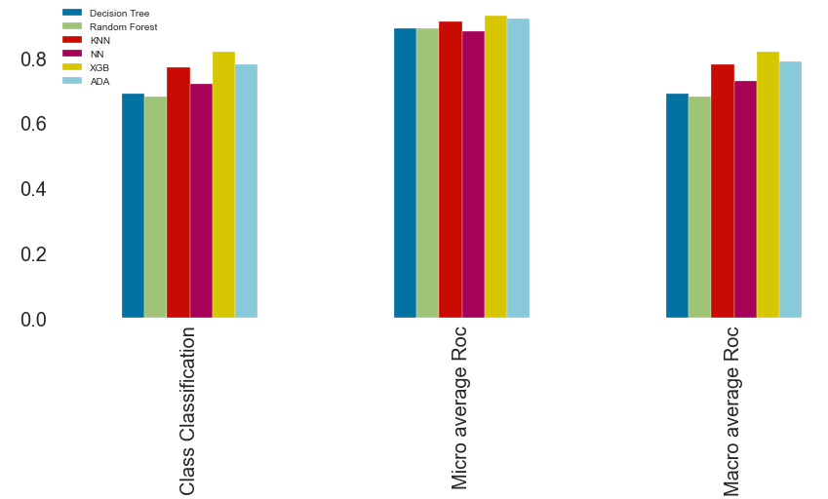

**Fig. 18.** Comparison of the AUC ROC Results.

**7 Conclusion :**

In this paper, we implemented certain classification algorithms on the dataset taken from Kaggle named IBM HR Analytics & Performance dataset having 35 features for the prediction of employee attrition. We can obtain 88% accuracy when we use the eXtreme Gradient Boosting algorithm. When we observe our model, it is giving best and balancing precision and recall which tells that our model considered both type 1 error and type 2 error reductions.

In future, we will try to build a deep learning model with Convolutional Neural Network with more data. The dataset we used in this paper consists of around 1500 rows which are less. If we get more data from any research organization or any competition then our model is regularized very well in the upcoming model. As we know the logic of machine learning lies in learning from more data leading to better precision in prediction. We also plan to apply deep learning models to deal with complex features to attain better accurate prediction.

**8 References :**

1. David J. Storey,” Understanding the Small Business Sector: Reflections and Confessions”.
2. Jantan, Hamidah Jantan et al. “Human Talent Prediction in HRM using C4.5 Classification Algorithm “ (IJCSE) International Journal on Computer Science and Engineering Vol. 02, No. 08, 2010, 2526-2534.
3. Nagadevara, V., Srinivasan, V. & Valk, R. (2008). Establishing a Link Between Employee Turnover and Withdrawal Behaviours: Application of Data Mining Techniques, Research and Practice in Human Resource Management, 16(2), 81-99.
4. Pankaj Ajit, “Prediction of Employee Turnover in Organizations using Machine Learning Algorithms A case for Extreme Gradient Boosting” International Journal of Advanced Research in Artificial Intelligence, Vol. 5, No. 9, 2016.
5. Joao Marcos de Oliveira, Matthäus P. Zylka, Peter A. Gloor, and Tushar Joshi:” Mirror, Mirror on the Wall, Who Is Leaving of Them All: Predictions for Employee Turnover with Gated Recurrent Neural Networks” © Springer Nature Switzerland AG 2019 Y. Song et al. (eds.), Collaborative Innovation Networks, Studies on Entrepreneurship, Structural Change and Industrial Dynamics, <https://doi.org/10.1007/978-3-030-17238-1_2>.
6. Xiang Gao, Junhao Wen, and Cheng Zhang:” An Improved Random Forest Algorithm for Predicting Employee Turnover” Volume 2019, Article ID 4140707, <https://doi.org/10.1155/2019/4140707>.
7. Yue Zhao, Maciej K. Hryniewicki, Francesca Cheng, Boyang Fu and Xiaoyu Zhu:” Employee Turnover Prediction with Machine Learning: A Reliable Approach” © Springer Nature Switzerland AG 2019 K. Arai et al. (Eds.): IntelliSys 2018, AISC 869, pp. 737–758, 2019. <https://doi.org/10.1007/978-3-030-01057-7_56>.
8. 8)Rahul Yedida, Rahul Reddy, Rakshit Vahi, Abhilash, Rahul J, Deepti Kulkarni:” Employee Attrition Prediction”, <https://arxiv.org/ftp/arxiv/papers/1806/1806.10480.pdf>.
9. H. S. Jung and H. H. Yoon, “Error management culture and turnover intent among food and beverage employees in deluxe hotels: the mediating effect of job satisfaction,” Service Business, vol. 11, no. 4, pp. 785–802, 2017.
10. L. J. Labrague, D. Gloe, D. M. McEnroe, K. Konstantinos, and P. Colet, “Factors influencing turnover intention among registered nurses in Samar Philippines,” Applied Nursing Research, vol. 39, pp. 200–206, 2018.
11. Amir Mohammad Esmaieeli Sikaroudi, RouzbehGhousi, Ali EsmaieeliSikaroudi:” A data mining approach to employee turnover prediction (case study: Arak automotive parts manufacturing)” Journal of Industrial and Systems Engineering Vol. 8, No. 4, pp106-121 Autumn 2015.
12. Shikha N. Khera, Divya: “Predictive Modelling of Employee Turnover in Indian IT Industry Using Machine Learning Techniques” Vision 23(1) 12–21, 2019 © 2019 DOI: 10.1177/0972262918821221 journals.sagepub.com/home/vis.
13. Ramakrishnan Raman, Sandeep Bhattacharya, Dhanya Pramod, (2018) "Predict employee attrition by using predictive analytics", Benchmarking: An International Journal, [https://doi.org/10.1108/ BIJ-03-2018-0083](https://doi.org/10.1108/%20BIJ-03-2018-0083).
14. Harlieen Bindra, Krishna Sehgal and Rachna Jain:” Optimisation of C5.0 Using Association Rules and Prediction of Employee Attrition” © Springer Nature Singapore Pte Ltd. 2019 S. Bhattacharyya et al. (eds.), International Conference on Innovative Computing and Communications, Lecture Notes in Networks and Systems 56, <https://doi.org/10.1007/978-981-13-2354-6_3>.
15. Devesh Kumar Srivastava and Priyanka Nair:” Employee Attrition Analysis Using Predictive Techniques” © Springer International Publishing AG 2018 S.C. Satapathy and A. Joshi (eds.), Information and Communication Technology for Intelligent Systems (ICTIS 2017) - Volume 1, Smart Innovation, Systems and Technologies 83, DOI 10.1007/978-3-319-63673-3_35.